Data Types in Java

Data types specify the different sizes and values that can be stored in the variable. There are two types of data types in Java:

1. **Primitive data types:** The primitive data types include boolean, char, byte, short, int, long, float and double.
2. **Non-primitive data types:** The non-primitive data types include Classes, Interfaces, and Arrays.

## Java Primitive Data Types

In Java language, primitive data types are the building blocks of data manipulation. These are the most basic data types available in Java language.

There are 8 types of primitive data types:

* boolean data type
* byte data type
* char data type
* short data type
* int data type
* long data type
* float data type
* double data type

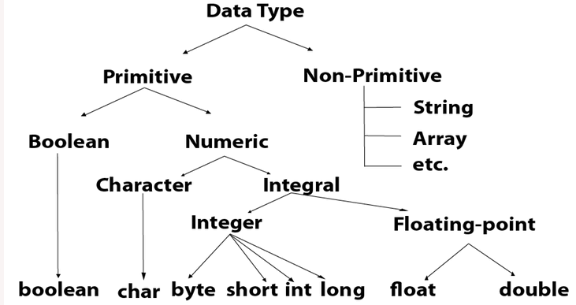

|  |  |  |
| --- | --- | --- |
| **Data Type** | **Default Value** | **Default size** |
| boolean | false | 1 bit |
| char | '\u0000' | 2 byte |
| byte | 0 | 1 byte |
| short | 0 | 2 byte |
| int | 0 | 4 byte |
| long | 0L | 8 byte |
| float | 0.0f | 4 byte |
| double | 0.0d | 8 byte |

## Boolean Data Type

The Boolean data type is used to store only two possible values: true and false.

## Byte Data Type

 8-bit signed two's complement integer.

Its value-range lies between -128 to 127 (inclusive).

Its default value is 0.

## Short Data Type

The short data type is a 16-bit signed two's complement integer.

Its value-range lies between -32,768 to 32,767 (inclusive).

Its default value is 0.

## Int Data Type

The int data type is a 32-bit signed two's complement integer.

Its value-range lies between - 2,147,483,648 (-2^31) to

2,147,483,647 (2^31 -1) (inclusive).  Its default value is 0.

## Long Data Type

The long data type is a 64-bit two's complement integer.

Its value-range lies between -9,223,372,036,854,775,808 (-2^63) to 9,223,372,036,854,775,807 (2^63 -1) (inclusive).

Its default value is 0.

## Float Data Type

The float data type is a single-precision 32-bit.

It is recommended to use a float (instead of double) if you need to save memory in large arrays of floating point numbers.

Its default value is 0.0F.

## Double Data Type

The double data type is a double-precision 64-bit floating point.

The double data type is generally used for decimal values just like float.

Its default value is 0.0d.

## Char Data Type

The char data type is a single 16-bit Unicode character.

Its value-range lies between '\u0000' (or 0) to '\uffff' (or 65,535 inclusive).

The char data type is used to store characters.

byte myNum = 100;

short myNum = 5000;

int myNum = 100000;

long myNum = 15000000000L;

float myNum = 5.75f;

double myNum = 19.99d;

boolean isJavaFun = true;

boolean isFishTasty = false;

char myGrade = 'B';

### Why char uses 2 byte in java and what is \u0000 ?

It is because java uses Unicode system not ASCII code system. The \u0000 is the lowest range of Unicode system.

A primitive type has always a value, while non-primitive types can be null.

A primitive type starts with a lowercase letter, while a non-primitive type starts with an uppercase letter.